**Exercise 4: Creating and Configuring a Maven Project**

**Step 1: Create a New Maven Project**

* In IntelliJ IDEA:

1. Open IntelliJ IDEA
2. Click File → New → Project
3. Select Maven on the left
4. Uncheck Create from archetype
5. Click Next
6. Enter

* GroupId: org.example.library
* ArtifactId: LibraryManagement

1. Click Finish

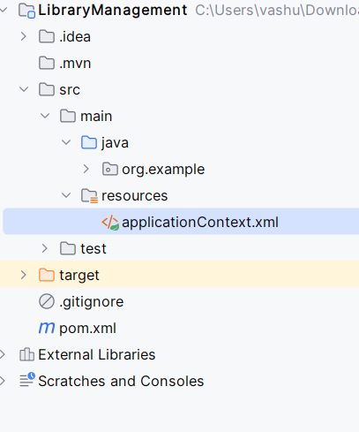

**Step 2: Add Spring Dependencies in pom.xml**

* Open pom.xml and add the following inside the <dependencies> tag:

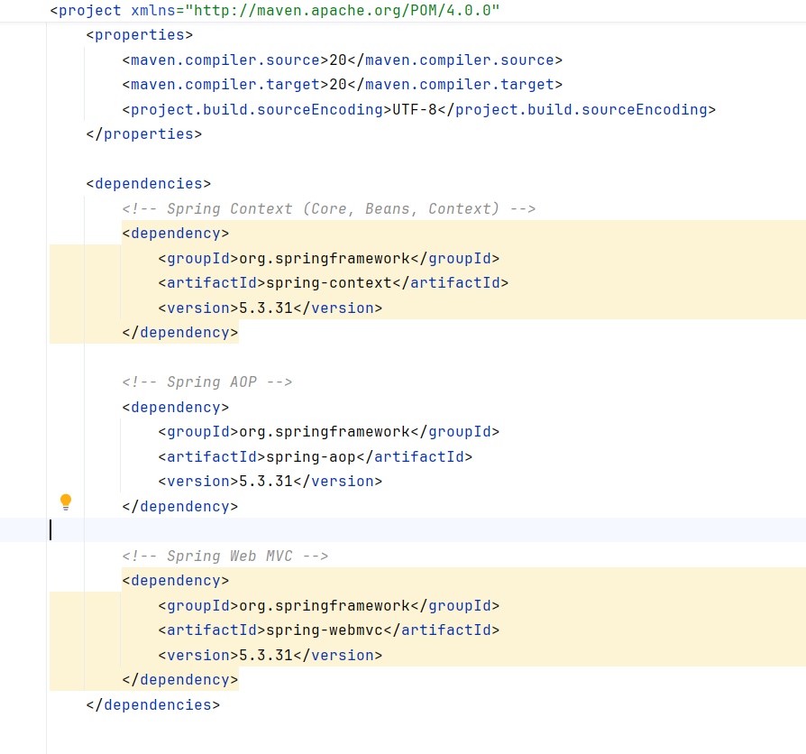

**Step 3: Configure Maven Compiler Plugin**

* Inside pom.xml, after <dependencies>, add the <build> section:

